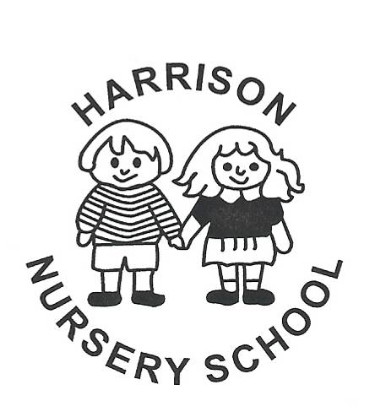
Information Leaflet for Parents – Number 3

Things you should know about

Our Outdoor Play
Outdoor play offers unique learning experiences which cannot be provided indoors. It is an ever changing space which provides new sights, sounds and sensations. It offers space and freedom for children to explore and investigate, to imagine and create and to try out new things.

Outdoor play is important for developing gross motor skills such as climbing, balancing, running and co-ordination of limbs etc., but there are also other fundamental aspects of learning involved in outdoor play.
Climbing up, over, through, on top of, inside and underneath objects builds not just physical dexterity, strength and confidence, but promotes mathematical concepts too. Research has shown that experience of whole body movement is essential for young children to build an understanding of abstract concepts such as height, weight, gradient and space which are vital aspects of early scientific and mathematical learning.

Movement is closely related to children's social and emotional growth. Being able to do something well makes a child feel confident, it boosts self esteem and sense of well being, giving a feeling of 'I can do it' which is vital to later learning. Vigorous movement is also crucial for children's health. Recent studies have shown that young children nowadays are not getting enough exercise to promote health in later life. It is part of our health policy to promote exercise and to develop good exercise habits in children which can have long term benefits for their fitness and health.

Creativity and imagination can thrive outdoors. Outdoors, firemen can put out the fire, picnickers can get dressed up, pack their bags and go for a picnic, horses can gallop and aeroplanes can fly! Dramatic play takes on a new dimension - the 3 Billy Goats Gruff story becomes much more meaningful when you can really trip trap over a wooden bridge!
Today, when there are fewer and fewer opportunities for safe, child initiated play, rich outdoor play becomes more important in fostering some of the essential aspects of childhood such as freedom and spontaneity. Our outdoor play can offer safe opportunities for children to take risks, to try things out, to develop confidence, and to express their exuberance and the sheer joy of being alive!

Outdoor play is much more that just physical learning. It can offer opportunities for learning in all areas of the curriculum, e.g. observing insects hiding under logs, seeing how long ice takes to melt, feeding birds, observing and discussing changes in the weather and the seasons and growing things in the garden are all part of our curriculum. And, of course, discussion of these topics promotes development of general knowledge, language and vocabulary.

As always, safety is paramount and we check all equipment regularly for splinters, rust, loose screws etc. Appropriate clothing and shoes are vital if children are to explore and climb safely. No long coats or smooth soled shoes! It is our aim that the children will know, understand and use safety rules and realise the importance of them. While being concerned for safety we also need to present children with stimulation and challenge. Children who have challenging opportunities and can handle them safely will grow in confidence.

We pretty much go outside every day of the year – in Harrison our motto is, ‘There is no such thing as bad weather; it’s about being properly prepared!’ Cold, damp, or wintry weather does not prevent us from going out - we encourage the children to wrap warmly. Equally, in warm weather we prepare children for play in the sun. We have legionnaires hats to protect heads and necks and we ask parents to apply sunblock in the morning. We avoid the heat of the midday sun as we are inside having dinner at this time.

We take the children walking in the grounds of the Junior High School and to local parks. We discuss with the children the importance of walking as a way of keeping fit. We hope that, by making our walks pleasurable experiences, the children will develop a positive attitude to walking which will stay with them. Our red hats - fleece hats, baseball caps or legionnaires hats according to the weather - help others to see us as well as helping the staff to identify and keep track of the children!

Our covered outdoor play area enables us to have some physical play even in the worst of weather. In this area children may be –
- Developing skills required for using tools at the workbench
- Building with large blocks
- Working in the sandpit with a variety of tools, blocks, pipes, water etc.
- Using books
- Drawing on the chalk board or on paper................
............and so on!

